
M&M Explosion Venting Fasteners are used in the construction of certain metal building environments. These environments may contain potentially hazardous material or operations which may pose an explosion threat. M&M Explosion Venting Fasteners assist in allowing explosive forces to escape or vent from the building.  The M&M Fastener System consists of a fastener-washer assembly with special aluminum alloy washers bonded with EPDM rubber to provide a weather tight seal. Certain applications require a centering device to prevent panel sag.  M&M Explosion Venting Fasteners are identified by a color code on the fastener body, which allows the head and washer to be color matched to any panel color.  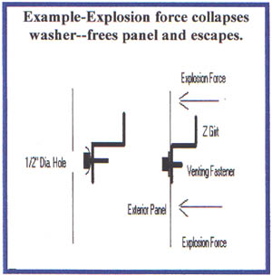  Benefits  - Our fastener-washer assembly is versatile enough to be used with virtually any wall panel.  - Reduces damage to building structure and equipment.  - Minimizes injury to personnel.  - Fasteners can be painted to match any panel color.  - Can be used to attach panels to wood and light weight or heavy gauge framing. |  | Product Features  - 300 Series stainless steel fastener for corrosion resistance.  - 3/8" Hex Head  - ".750" O.D. special aluminum alloy washer bonded to EPDM rubber.  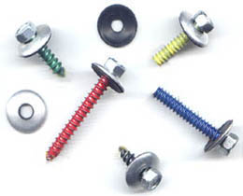  M&M Venting offers five release washer values. The number of fasteners to be used on a project is determined by the release value of the fastener, desired psf release, girt spacing, type of panel, and area to be vented.  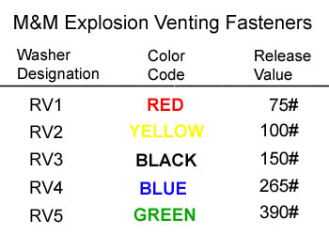
Calculations  - Determine area to be vented.  - Apply desired release pressure per square foot to area to be vented  - Divide by desired number of fasteners per structural location to determine explosion venting washer.  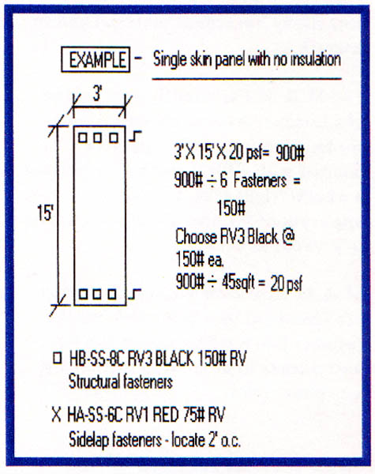  - M&M Venting Co. provides fastener layouts with detailed installation instructions.  - We provide in-house design assistance |  | Installation:  Panel to Structure  Wall panel and structural member are both drilled with the proper size drill bit to accommodate the fastener type and diameter. Then the hole in the panel is enlarged to 1/2" diameter. The fastener assembly is installed by hand to avoid over tightening and distortion of the special aluminum alloy washer. Damage to washer may alter its release value.  Panel to Panel  Both panels are drilled with the proper size drill bit, then the hole in the overlapping panel is enlarged to 1/2" diameter.  Contact Information:  M&M Venting Company  P.O. Box 122  719 W. Main St.  Locust, NC 28097  (704) 888-3108  (704) 888-0026 fax  http://www.mmventing.com/  Monty R. Soots  Sales  info@mmventing.com  Note:  Next Day Shipping available for most job requirements.

